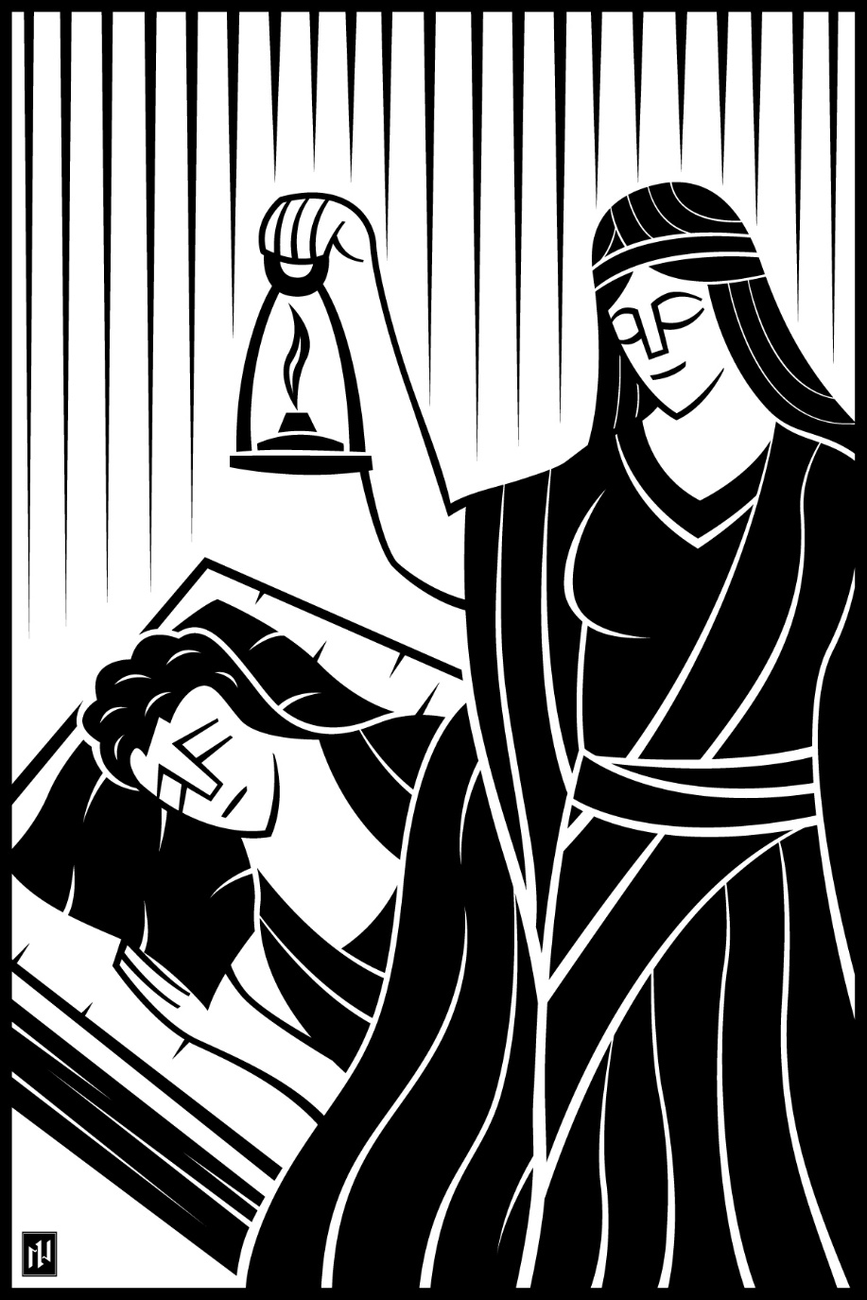
First Sunday of Advent
November 29, 2020
Christ the Vine Lutheran Church

WELCOME TO WORSHIP
AT
Christ the Vine Lutheran Church

29581 N. Gen. Kearny Rd., Temecula, CA 92591
Church Office - (951) 699-Vine(8463)
Wisconsin Ev. Lutheran Synod (WELS)
www.christthevine.com
information@christthevine.com
Pastor Curtis Lyon
(951) 764-3419

We welcome you to worship with us. We gather to hear our God speak to us through his Word. We remember what he has done for us through Word and Sacrament. We praise him through our songs and speak to him in prayer. We are sent into the world to proclaim his name to everyone. Thank you for joining us and allowing us the privilege of sharing the Word of God with you.
There is a guest book at the back of the church. If you are visiting please sign the book before or after worship. We would appreciate having your address and phone number so we can have a record of your visit and get better acquainted.

FOR YOUR CONVENIENCE:

A nursery is available through the classroom on the right of the church. Just beyond is a restroom with a changing area. Audio speakers are available in the classroom and nursery area if your children need your attention. The volume control on the wall controls the speaker.

SERVICE OF MORNING PRAISE

OPENING HYMN CW#7, “Rejoice, Rejoice, Believers”

M: O Lord, open my lips.
M: Hasten to save me, O God.
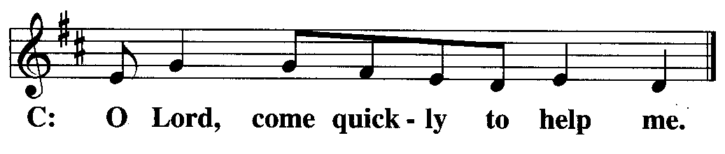

M: Praise be to God, the Father, the Son, and the Holy Spirit: let us worship him.

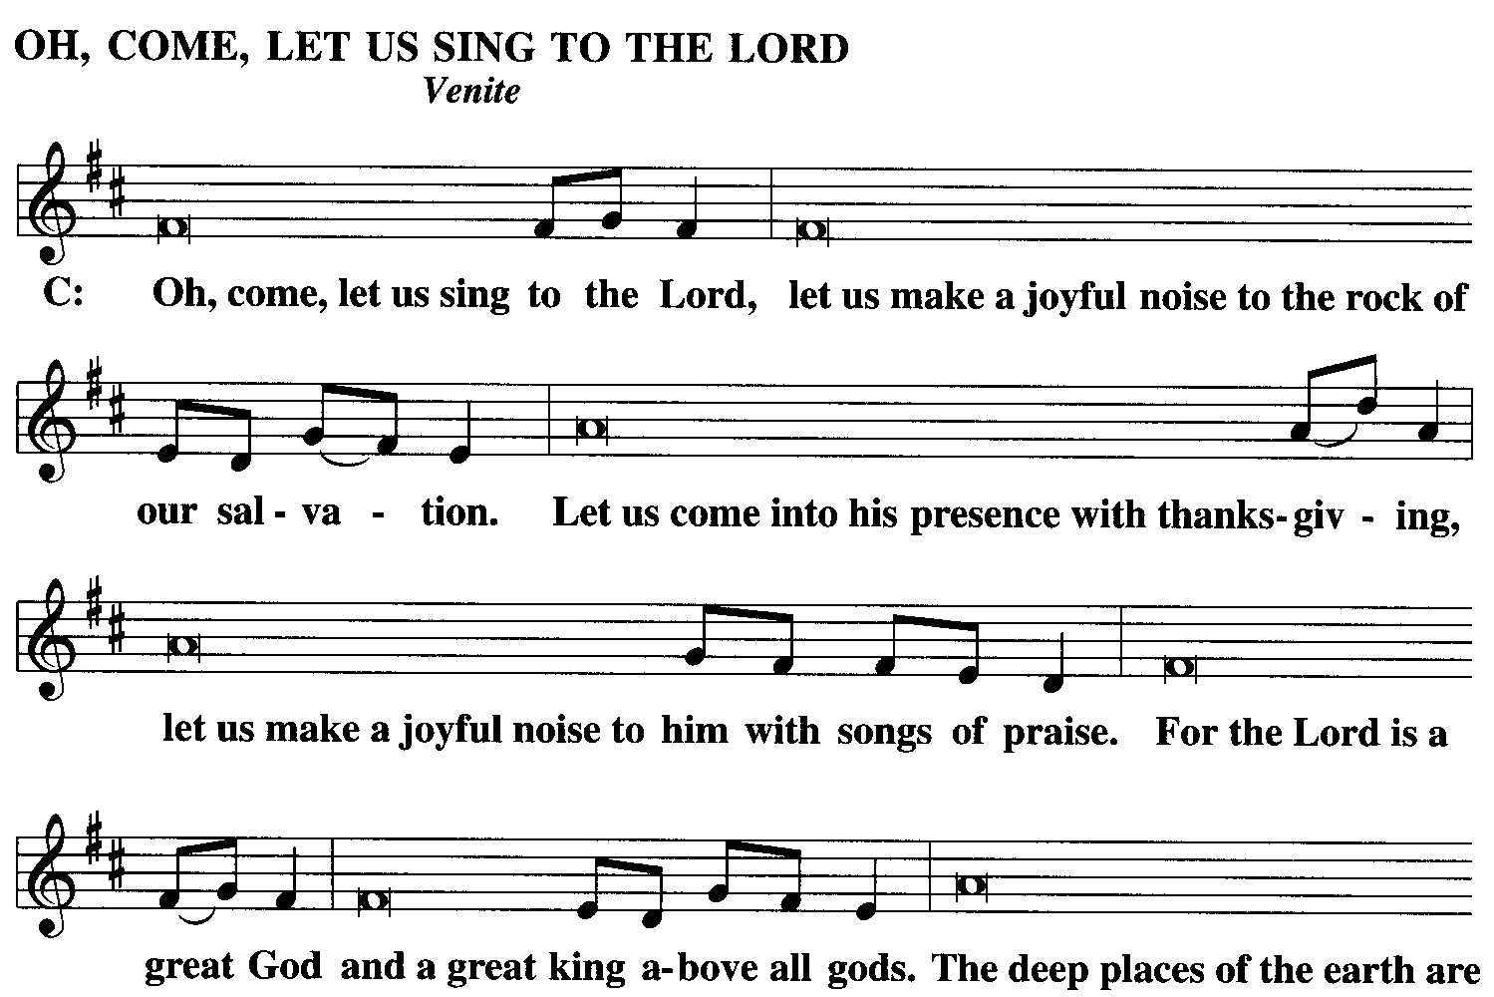

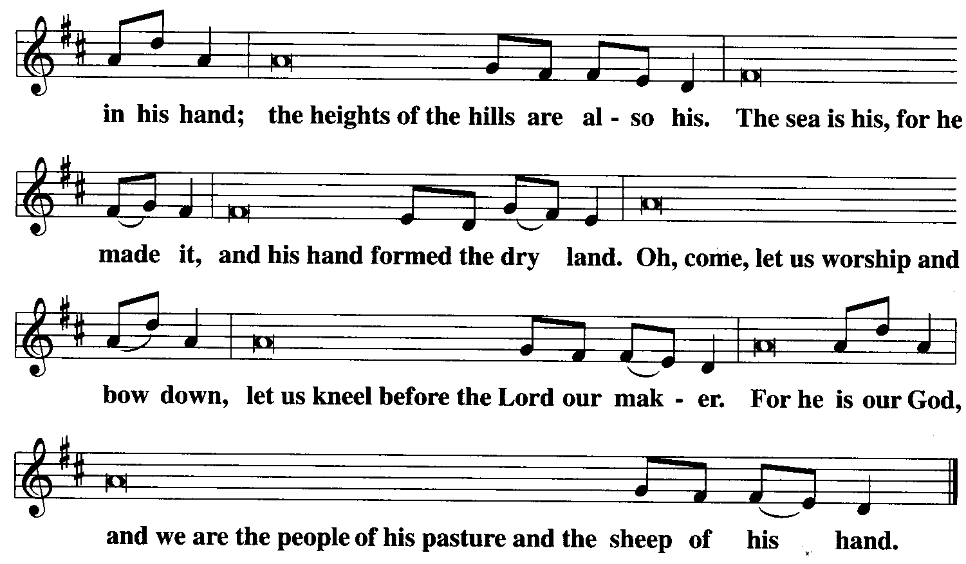

THE FIRST LESSON Isaiah 63:16b, 17; 64:1-8 (NIV)
¹⁶ But you are our Father,
though Abraham does not know us
or Israel acknowledge us;
you, Lord, are our Father,
our Redeemer from of old is your name.
¹⁷ Why, Lord, do you make us wander from your ways
and harden our hearts so we do not revere you?
Return for the sake of your servants,
the tribes that are your inheritance.
64 ^{[a]}Oh, that you would rend the heavens and come down,
that the mountains would tremble before you!
² As when fire sets twigs ablaze
and causes water to boil,
come down to make your name known to your enemies
and cause the nations to quake before you!
³ For when you did awesome things that we did not expect,
you came down, and the mountains trembled before you.
⁴ Since ancient times no one has heard,
no ear has perceived,
no eye has seen any God besides you,
who acts on behalf of those who wait for him.
⁵ You come to the help of those who gladly do right,
who remember your ways.
But when we continued to sin against them,
you were angry.
How then can we be saved?
⁶ All of us have become like one who is unclean,
and all our righteous acts are like filthy rags;
we all shrivel up like a leaf,
and like the wind our sins sweep us away.
⁷ No one calls on your name
or strives to lay hold of you;
for you have hidden your face from us
and have given us over to^{[b]} our sins.
⁸ Yet you, Lord, are our Father.
We are the clay, you are the potter;
we are all the work of your hand.

Psalm 24

The earth is the LORD’S, and everything in it,*

the world, and all who live in it;

for he founded it upon the seas*

and established it upon the waters.

Who may ascend the hill of the LORD?*

Who may stand in his holy place?

He who has clean hands and a pure heart,*

he will receive blessing from God his Savior.

Refrain

Lift up your heads, O you gates;

be lifted up, you ancient doors,*

that the King of glory may come in.

Who is this King of glory?*

The LORD strong and mighty,

the LORD mighty in battle.

Lift up your heads, O you gates;

lift them up, you ancient doors,*

that the King of glory may come in.

Who is he, this King of glory?*

The LORD Almighty—he is the King of glory.

Glory be to the Father and to the Son*

and to the Holy Spirit,

as it was in the beginning,*

is now, and will be forever. Amen.

Refrain

THE SECOND LESSON 1 Corinthians 1:3-9 (NIV)

³ Grace and peace to you from God our Father and the Lord Jesus Christ.

⁴ I always thank my God for you because of his grace given you in Christ Jesus. ⁵ For in him you have been enriched in every way—with all kinds of speech and with all knowledge— ⁶ God thus confirming our testimony about Christ among you. ⁷ Therefore you do not lack any spiritual gift as you eagerly wait for our Lord Jesus Christ to be revealed. ⁸ He will also keep you firm to the end, so that you will be blameless on the day of our Lord Jesus Christ. ⁹ God is faithful, who has called you into fellowship with his Son, Jesus Christ our Lord.

VERSE OF THE DAY
Alleluia. He who testifies to these things says, “Yes, I am coming soon.” Amen. Come, Lord Jesus. Alleluia. (Revelation 22:20)

GOSPEL Mark 13:32-37 (NIV)

³² “But about that day or hour no one knows, not even the angels in heaven, nor the Son, but only the Father. ³³ Be on guard! Be alert^{[a]}! You do not know when that time will come. ³⁴ It’s like a man going away: He leaves his house and puts his servants in charge, each with their assigned task, and tells the one at the door to keep watch.

³⁵ “Therefore keep watch because you do not know when the owner of the house will come back—whether in the evening, or at midnight, or when the rooster crows, or at dawn. ³⁶ If he comes suddenly, do not let him find you sleeping. ³⁷ What I say to you, I say to everyone: ‘Watch!’”

Hymn of the Day CW#2, “Savior of the Nations, Come”

Sermon Sermon Text: Mark 13:32-37

WATCH!

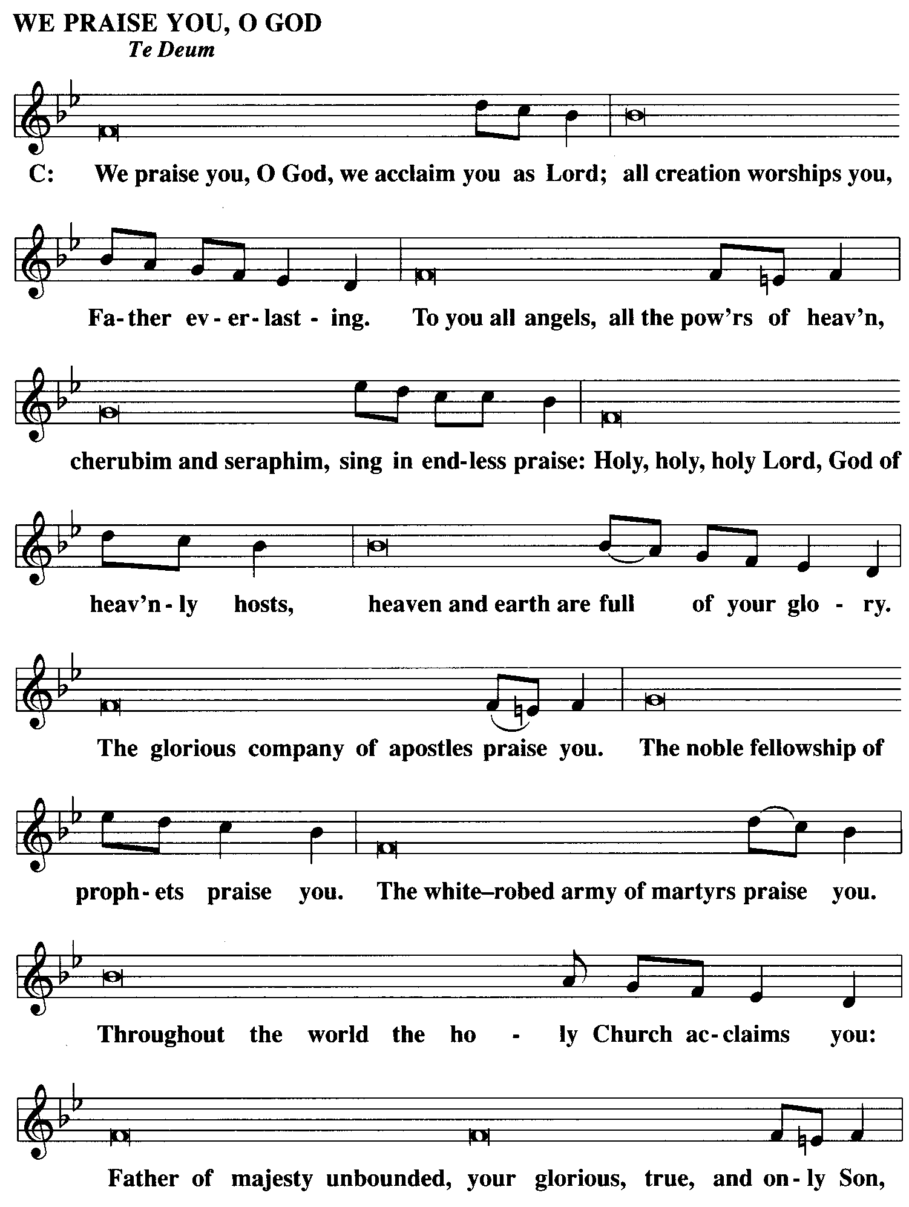

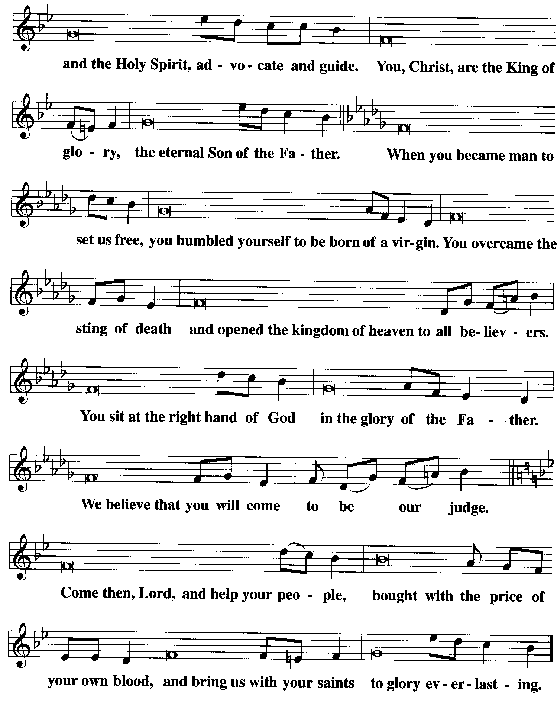
BE SEATED
OFFERING

Out of loving concern for each other and in keeping with social distance guidelines, we will not be passing around an offering plate at this time. Instead, you may deposit your offerings in the offering plate after the church service has concluded (located by the entry way). Alternatively, you may give electronically through our Church App or by going to Christhtevine.com

STAND

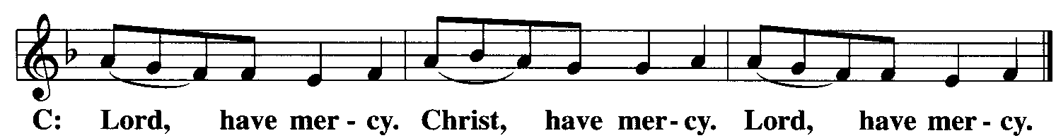
M: In the morning, O Lord, I call to you; be merciful to me and hear my prayer.

LORD'S PRAYER

Our Father, who art in heaven, hallowed be thy name, thy kingdom come, thy will be done on earth as it is in heaven. Give us this day our daily bread and forgive us our trespasses as we forgive those who trespass against us; and lead us not into temptation, but deliver us from evil. For thine is the kingdom and the power and the glory forever and ever. Amen.

PRAYER FOR GRACE

M: O Lord God, our heavenly Father, almighty and everlasting God, you have brought us safely to this new day. Defend us with your mighty power, and grant that this day we neither fall into sin nor run into any kind of danger; and in all we do, direct us to what is right in your sight, through Jesus Christ, you Son, our Lord.

C: Amen.

M: Let us praise the Lord.
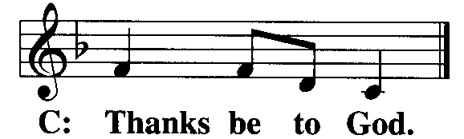

BLESSING

M: The grace of our Lord Jesus Christ and the love of God and the fellowship of the Holy Spirit be with you all.
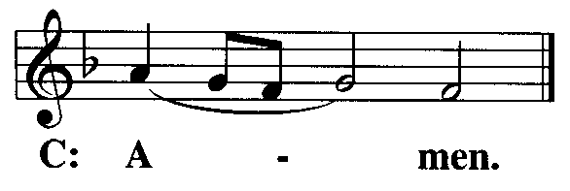

BE SEATED

CLOSING HYMN CW#6, “Come, O Long-Expected Jesus”
Holiday Worship Schedule:

December 9th - 6:30 PM-
Advent Service - *Dependent on County Guidelines*
(A 30-minute meditative indoor service, no singing)
December 24th - 7:00 PM-
Outdoor Christmas Eve Service
December 25th - 10:00 AM-
Outdoor Christmas Day Service - Lessons and Carols
December 31st - 6:30 PM-
Outdoor New Year's Eve Servic

